

**ARTIFICIAL INTELLIGENCE**

**(Subject Code: (18CSC305J)**

**B.TECH III Year / VI Semester**



# DEPARTMENT OF COMPUTER SCIENCE

**SRM INSTITUTE OF SCIENCE & TECHNOLOGY,**

**Delhi NCR CAMPUS, MODINAGAR**

**SIKRI KALAN, DELHI MEERUT ROAD, DIST. – GHAZIABAD - 201204**

[**www.srmup.in**](http://www.srmup.in)

**Even Semester (Jan-June 2022)**

Submitted To: Submitted By:

Mrs. Shivani Rohilla Aman Tawar

Assistant Professor (RA1911003030179)

Department of CSE CSE – III yr - G

SRM-IST



**BONAFIDE CERTIFICATE**

*Certified to be the bonafide record of work done by Aman Tawar*

*Of 6th semester 3rd year B.TECH degree course in SRM INSTITUTE OF SCIENCE & TECHNOLOGY, DELHI-NCR Campus for the Department of* ***Computer Science & Engineering,*** *in Artificial Intelligence Laboratory during the academic year* ***2021-22.***

**Lab In charge Head of the department**

*Submitted for end semester examination held on __/____/___ at SRM INSTITUTE OF SCIENCE & TECHNOLOGY, DELHI-NCR Campus.*

***Internal Examiner-I Internal Examiner-II***

## INDEX

|  |  |  |  |  |  |
| --- | --- | --- | --- | --- | --- |
| Exp. No. | Title of Experiment | Page No. | Date of Experiment | Date of Completion of Experiment | Teacher’s Signature |
| **1** | Implementation of Toy problem .Example-Implement water jug problem | 5-13 |  |  |  |
| **2** | Developing Agent Program for Real World Problem. | 14-17 |  |  |  |
| **3** | Implementation of Constrain satisfaction problem, Example: Implement N- queen Problem | 18-19 |  |  |  |
| **4** | To Implementation and Analysis of BFS and DFS for Application. | 20-21 |  |  |  |
| **5** | To implement Best first search and A* algorithm. | 22-29 |  |  |  |
| **6** | To implement Minimax Algorithm. | 30-31 |  |  |  |
| **7** | Implementation of unification and resolution for real world problems. | 32-33 |  |  |  |
| **8** | Implementation of knowledge representation schemes – use cases. | 34-36 |  |  |  |
| **9** | Implementation of uncertain methods for an application. | 37 |  |  |  |
| **10** | Implementation of block world problem. | 38-39 |  |  |  |
| **11** | Implementation Of learning algorithm | 40-43 |  |  |  |
| **12** | Development of ensemble model | 44-45 |  |  |  |
| **13** | Implementation of NLP Program | 46 |  |  |  |
| **14** | Deep learning Project in Python | 47-48 |  |  |  |

**Experiment 1**

* **Aim –** Implementation of Toy problem

Example-Implement water jug problem.

* **Algorithm –**

| **Rule** | **State** | **Process** |
| --- | --- | --- |
| **1** | (X,Y | X<4) | (4,Y)  {Fill 4-gallon jug} |
| **2** | (X,Y |Y<3) | (X,3)  {Fill 3-gallon jug} |
| **3** | (X,Y |X>0) | (0,Y)  {Empty 4-gallon jug} |
| **4** | (X,Y | Y>0) | (X,0)  {Empty 3-gallon jug} |
| **5** | (X,Y | X+Y>=4 ^ Y>0) | (4,Y-(4-X))  {Pour water from 3-gallon jug into 4-gallon jug until 4-gallon jug is full} |
| **6** | (X,Y | X+Y>=3 ^X>0) | (X-(3-Y),3)  {Pour water from 4-gallon jug into 3-gallon jug until 3-gallon jug is full} |
| **7** | (X,Y | X+Y<=4 ^Y>0) | (X+Y,0)  {Pour all water from 3-gallon jug into 4-gallon jug} |
| **8** | (X,Y | X+Y <=3^ X>0) | (0,X+Y)  {Pour all water from 4-gallon jug into 3-gallon jug} |
| **9** | (0,2) | (2,0)  {Pour 2 gallon water from 3 gallon jug into 4 gallon jug} |

* **Code –**

print("Water jug problem")

x=int(input("Enter X : "))

y=int(input("Enter Y : "))

while True:

rn=int(input("Enter the rule no. : "))

if rn==2:

if y<3:

x=0

y=3

if rn==3:

if x>0:

x=0

y=3

if rn==5:

if x+y>4:

x=4

y=y-(4-x)

if rn==7:

if x+y<4:

x=x+y

y=0

if rn==9:

x=2

y=0

print("X=",x)

print("Y=",y)

if x==2:

print("The result is a goal state")

break

* **Result –**
* 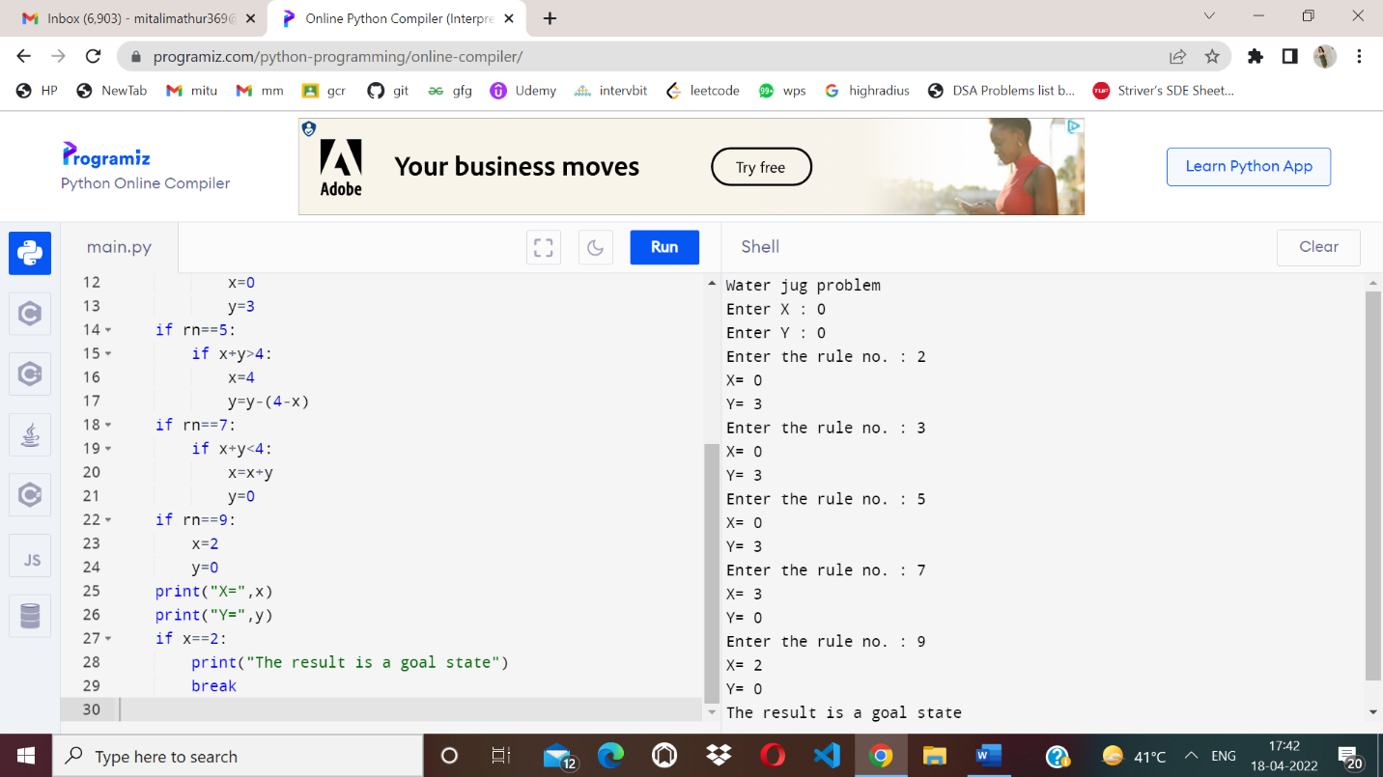

**TIC TAC TOE**

import random

class TicTacToe:

def __init__(self):

self.board = []

def create_board(self):

for i in range(3):

row = []

for j in range(3):

row.append('-')

self.board.append(row)

def get_random_first_player(self):

return random.randint(0, 1)

def fix_spot(self, row, col, player):

self.board[row][col] = player

def is_player_win(self, player):

win = None

n = len(self.board)

# checking rows

for i in range(n):

win = True

for j in range(n):

if self.board[i][j] != player:

win = False

break

if win:

return win

# checking columns

for i in range(n):

win = True

for j in range(n):

if self.board[j][i] != player:

win = False

break

if win:

return win

# checking diagonals

win = True

for i in range(n):

if self.board[i][i] != player:

win = False

break

if win:

return win

win = True

for i in range(n):

if self.board[i][n - 1 - i] != player:

win = False

break

if win:

return win

return False

for row in self.board:

for item in row:

if item == '-':

return False

return True

def is_board_filled(self):

for row in self.board:

for item in row:

if item == '-':

return False

return True

def swap_player_turn(self, player):

return 'X' if player == 'O' else 'O

def show_board(self):

for row in self.board:

for item in row:

print(item, end=" ")

print()

def start(self):

self.create_board()

player = 'X' if self.get_random_first_player() == 1 else 'O'

while True:

print(f"Player {player} turn")

self.show_board()

# taking user input

row, col = list(

map(int, input("Enter row and column numbers to fix spot: ").split()))

print()

# fixing the spot

self.fix_spot(row - 1, col - 1, player)

# checking whether current player is won or not

if self.is_player_win(player):

print(f"Player {player} wins the game!")

break

# checking whether the game is draw or not

if self.is_board_filled():

print("Match Draw!")

break

# swapping the turn

player = self.swap_player_turn(player)

# showing the final view of board

print()

self.show_board()

# starting the game

tic_tac_toe = TicTacToe()

tic_tac_toe.start()

**RESULT:**

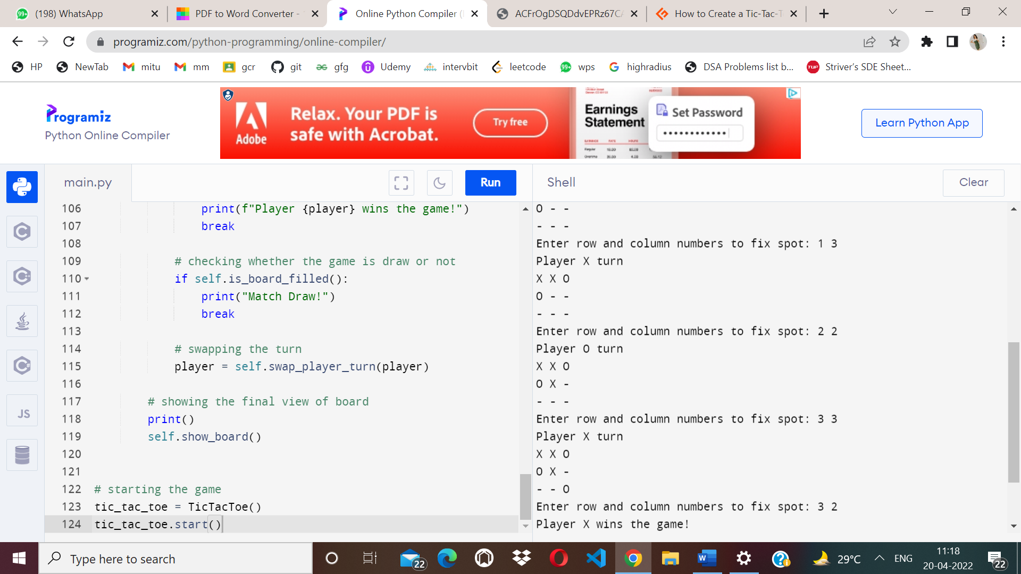

**SUDUKO:**

board = [

[7,8,0,4,0,0,1,2,0],

[6,0,0,0,7,5,0,0,9],

[0,0,0,6,0,1,0,7,8],

[0,0,7,0,4,0,2,6,0],

[0,0,1,0,5,0,9,3,0],

[9,0,4,0,6,0,0,0,5],

[0,7,0,3,0,0,0,1,2],

[1,2,0,0,0,7,4,0,0],

[0,4,9,2,0,6,0,0,7]

]

def solve(bo):

find = find_empty(bo)

if not find:

return True

else:

row, col = find

for i in range(1,10):

if valid(bo, i, (row, col)):

bo[row][col] = i

if solve(bo):

return True

bo[row][col] = 0

return False

def valid(bo, num, pos):

# Check row

for i in range(len(bo[0])):

if bo[pos[0]][i] == num and pos[1] != i:

return False

# Check column

for i in range(len(bo)):

if bo[i][pos[1]] == num and pos[0] != i:

return False

# Check box

box_x = pos[1] // 3

box_y = pos[0] // 3

for i in range(box_y*3, box_y*3 + 3):

for j in range(box_x * 3, box_x*3 + 3):

if bo[i][j] == num and (i,j) != pos:

return False

return True

def print_board(bo):

for i in range(len(bo)):

if i % 3 == 0 and i != 0:

print("- - - - - - - - - - - - - ")

for j in range(len(bo[0])):

if j % 3 == 0 and j != 0:

print(" | ", end="")

if j == 8:

print(bo[i][j])

else:

print(str(bo[i][j]) + " ", end="")

def find_empty(bo):

for i in range(len(bo)):

for j in range(len(bo[0])):

if bo[i][j] == 0:

return (i, j) # row, col

return None

print_board(board)

solve(board)

print("___________________")

print_board(board)

RESULT:

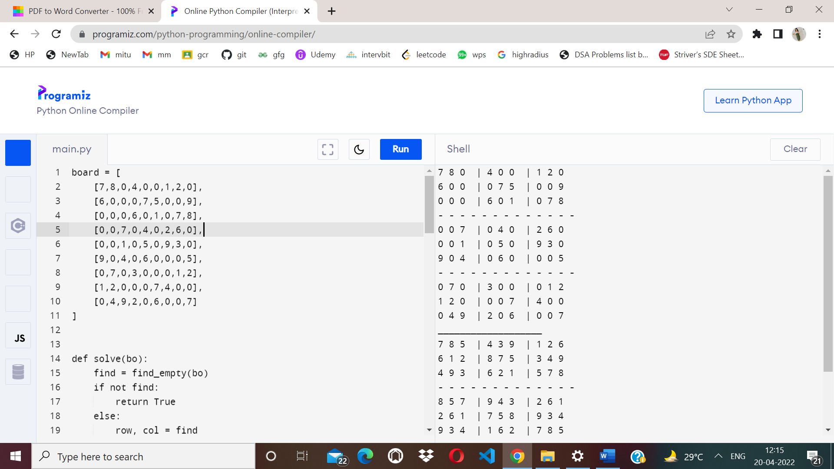

**Experiment 2**

* **Aim –** Developing Agent Program for Real World Problem.
* **Code –**

import random

class Environment(object):

def __init__(self):

self.locationCondition = {'A': '0', 'B': '0'}

self.locationCondition['A'] = random.randint(0, 1)

self.locationCondition['B'] = random.randint(0, 1)

class SimpleReflexVacuumAgent(Environment):

def __init__(self, Environment):

print (Environment.locationCondition)

Score = 0

vacuumLocation = random.randint(0, 1)

if vacuumLocation == 0:

print ("Vacuum is randomly placed at Location A")

if Environment.locationCondition['A'] == 1:

print ("Location A is Dirty. ")

Environment.locationCondition['A'] = 0;

Score += 1

print ("Location A has been Cleaned. :D")

if Environment.locationCondition['B'] == 1:

print ("Location B is Dirty.")

print ("Moving to Location B...")

Score -= 1

Environment.locationCondition['B'] = 0;

Score += 1

print ("Location B has been Cleaned :D.")

else:

if Environment.locationCondition['B'] == 1:

print ("Location B is Dirty.")

Score -= 1

print ("Moving to Location B...")

Environment.locationCondition['B'] = 0;

Score += 1

print ("Location B has been Cleaned. :D")

elif vacuumLocation == 1:

print ("Vacuum is randomly placed at Location B. ")

if Environment.locationCondition['B'] == 1:

print ("Location B is Dirty")

Environment.locationCondition['B'] = 0;

Score += 1

print ("Location B has been Cleaned")

if Environment.locationCondition['A'] == 1:

print ("Location A is Dirty")

Score -= 1

print ("Moving to Location A")

Environment.locationCondition['A'] = 0;

Score += 1

print ("Location A has been Cleaned")

else:

if Environment.locationCondition['A'] == 1:

print ("Location A is Dirty")

print ("Moving to Location A")

Score -= 1

Environment.locationCondition['A'] = 0;

Score += 1

print ("Location A has been Cleaned")

print (Environment.locationCondition)

print ("Performance Measurement: " + str(Score))

theEnvironment = Environment()

theVacuum = SimpleReflexVacuumAgent(theEnvironment)

* **Result –**
* 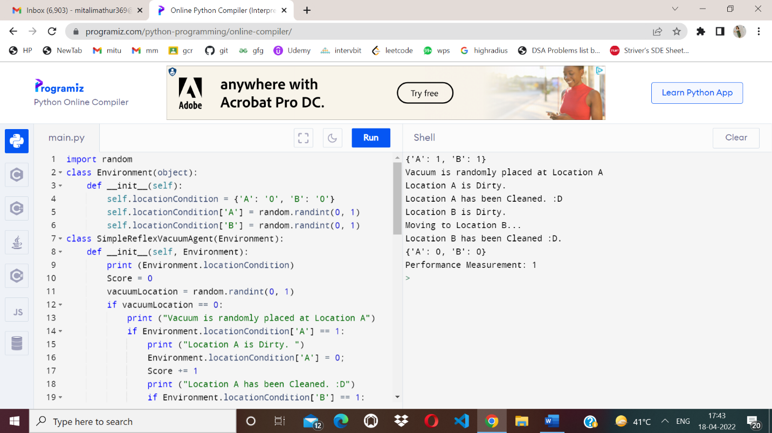

**GRAPH COLORING**

# Python3 program to implement greedy

# algorithm for graph coloring

def addEdge(adj, v, w):

adj[v].append(w)

# Note: the graph is undirected

adj[w].append(v)

return adj

# Assigns colors (starting from 0) to all

# vertices and prints the assignment of colors

def greedyColoring(adj, V):

result = [-1] * V

# Assign the first color to first vertex

result[0] = 0;

# A temporary array to store the available colors.

# True value of available[cr] would mean that the

# color cr is assigned to one of its adjacent vertices

available = [False] * V

# Assign colors to remaining V-1 vertices

for u in range(1, V):

# Process all adjacent vertices and

# flag their colors as unavailable

for i in adj[u]:

if (result[i] != -1):

available[result[i]] = True

# Find the first available color

cr = 0

while cr < V:

if (available[cr] == False):

break

cr += 1

# Assign the found color

result[u] = cr

# Reset the values back to false

# for the next iteration

for i in adj[u]:

if (result[i] != -1):

available[result[i]] = False

# Print the result

for u in range(V):

print("Vertex", u, " ---> Color", result[u])

# Driver Code

if __name__ == '__main__':

g1 = [[] for i in range(5)]

g1 = addEdge(g1, 0, 1)

g1 = addEdge(g1, 0, 2)

g1 = addEdge(g1, 1, 2)

g1 = addEdge(g1, 1, 3)

g1 = addEdge(g1, 2, 3)

g1 = addEdge(g1, 3, 4)

print("Coloring of graph 1 ")

greedyColoring(g1, 5)

g2 = [[] for i in range(5)]

g2 = addEdge(g2, 0, 1)

g2 = addEdge(g2, 0, 2)

g2 = addEdge(g2, 1, 2)

g2 = addEdge(g2, 1, 4)

g2 = addEdge(g2, 2, 4)

g2 = addEdge(g2, 4, 3)

print("\nColoring of graph 2")

greedyColoring(g2, 5)

**RESULT**:

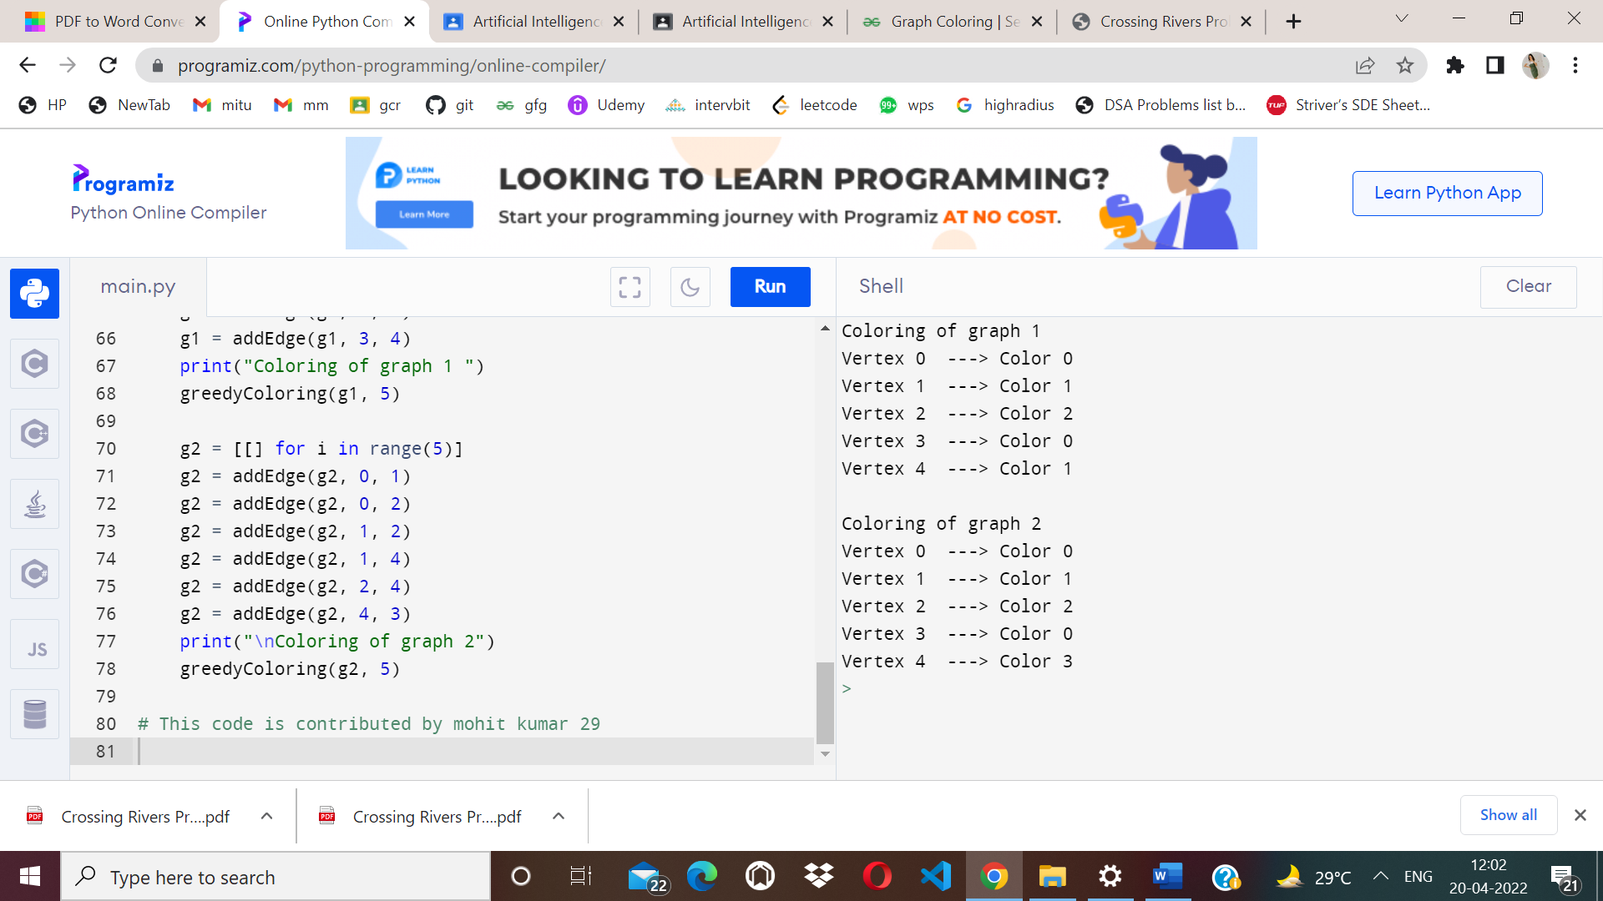

**Experiment 3**

* **Aim –** Implementation of Constraint satisfaction problem

Example: Implement N- queen Problem

* **Algorithm –**

while there are untried configurations

{

generate the next configuration

if queens don't attack in this configuration then

{

print this configuration;

}

}

* **Code –**

global N

N=int(input("enter no of queens : "))

def printSolution(board):

for i in range(N):

for j in range(N):

print(board[i][j],end=" ")

print(" ")

def isSafe(board,row,col):

for i in range(col):

if board[row][i]=='Q':

return False

for i,j in zip(range(row,-1,-1), range(col,-1,-1)):

if board[i][j]=='Q':

return False

for i,j in zip(range(row,N,1), range(col,-1,-1)):

if board[i][j]=='Q':

return False

return True

def solveNQUtil(board,col):

if col>=N:

return True

for i in range(N):

if isSafe(board,i,col):

board[i][col]='Q'

if solveNQUtil(board,col+1) == True:

return True

board[i][col]=0

return False

def solveNQ():

board = [[0 for i in range(N)] for j in range(N)]

if solveNQUtil(board,0)==False:

print("Solution does not exist")

return False

printSolution(board)

return True

solveNQ()

* **RESULT**:
* 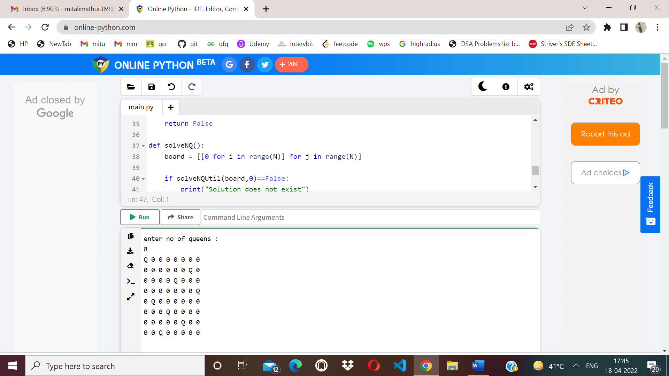

**Experiment 4**

* **Aim –** To Implementation and Analysis of BFS and DFS for Application.
* **Algorithm –**

1. Create a node list (Queue) that initially contains the first node N and mark it as visited.
2. Visit the adjacent unvisited vertex of N and insert it in a queue.
3. If there are no remaining adjacent vertices left, remove the first vertex from the queue mark it as visited, display it.
4. Repeat step 1 and step 2 until the queue is empty or the desired node is found.

* **Code –**

graph = {

'S': ['A', 'B'],

'A': ['C', 'D'],

'B': ['G','H'],

'C': ['E','F'],

'D': [],

'G': ['I'],

'H': [],

'E': ['K'],

'F': [],

'I': [],

'K': []

}

visited =[]

queue=[]

def bfs(visited,graph,node):

visited.append(node)

queue.append(node)

while queue:

P=queue.pop(0)

print(P,end=" ")

for neighbour in graph[P]:

if neighbour not in visited:

visited.append(neighbour)

queue.append(neighbour)

avisit=set()

def dfs(avisit,graph,node):

if node not in avisit:

print(node,end=" ")

avisit.add(node)

for neighbour in graph[node]:

dfs(avisit,graph,neighbour)

print("Breadth first search")

bfs(visited,graph,'S')

print("\nDepth first search")

dfs(avisit,graph,'S')

* **RESULT**:

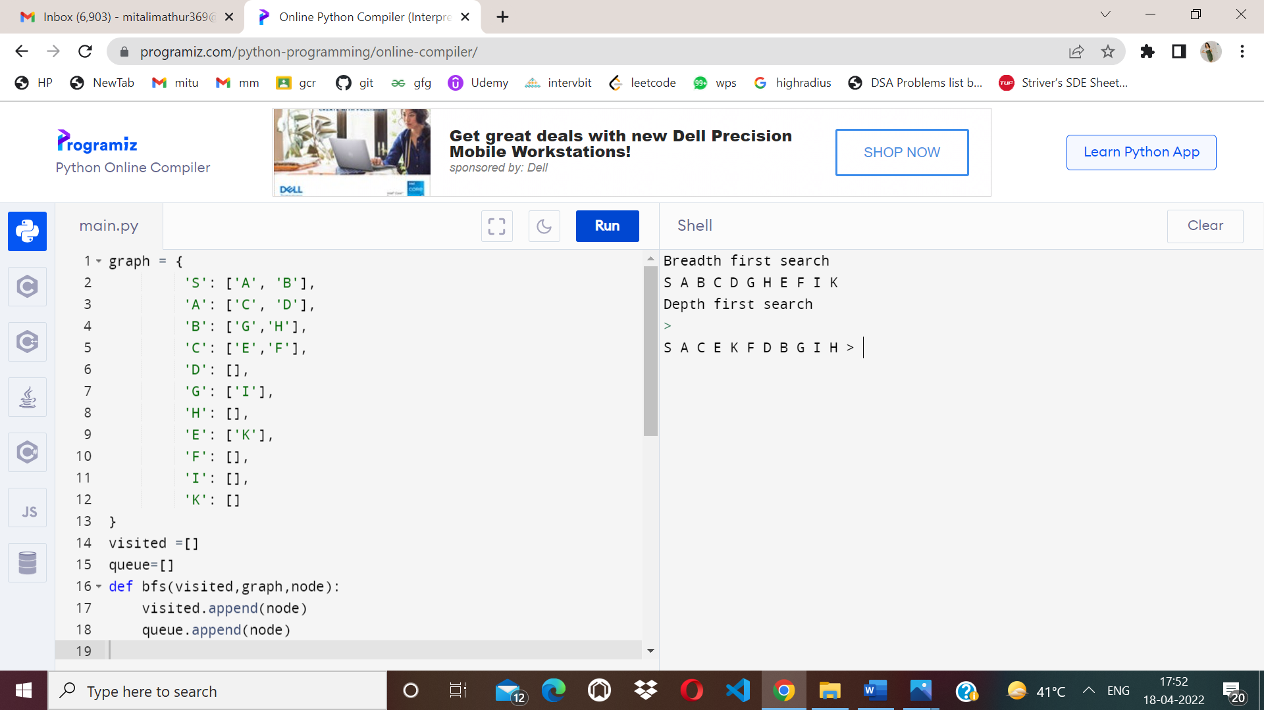

**Experiment 5**

* **Aim-**To implement Best First Search and A* algorithm.
* **Algorithm-**

1. **Best First Search-**

Step 1: Place the starting node into the OPEN list.

Step 2: If the OPEN list is empty, Stop and return failure.

Step 3: Remove the node n, from the OPEN list which has the lowest value of h(n), and places it in the CLOSED list.

If node n is goal then return

else

Step 4: Expand the node n, and generate and check the successors of node n. and find whether any node is a goal node or not. If any successor node is goal node, then return success and terminate the search, else proceed to Step 5.

Step 5: For each successor node, algorithm checks for evaluation function f(n), and then check if the node has been in either OPEN or CLOSED list. If the node has not been in both list, then add it to the OPEN list.

Step 6: Return to Step 2.

1. **A*-**

Step1: Place the starting node in the OPEN list.

Step 2: Check if the OPEN list is empty or not, if the list is empty then return failure and stops.

Step 3: Select the node from the OPEN list which has the smallest value of evaluation function (g+h), if node n is goal node then return success and stop, otherwise

Step 4:Expand node n and generate all of its successors, and put n into the closed list. For each successor n', check whether n' is already in the OPEN or CLOSED list, if not then compute evaluation function for n' and place into Open list.

Step 5: Else if node n' is already in OPEN and CLOSED, then it should be attached to the back pointer which reflects the lowest g(n') value.

Step 6: Return to Step 2.

* **Code-**

1. **Best First Search-**

# This class represent a graph

class Graph:

# Initialize the class

def __init__(self, graph_dict=None, directed=True):

self.graph_dict = graph_dict or {}

self.directed = directed

if not directed:

self.make_undirected()

# Create an undirected graph by adding symmetric edges

def make_undirected(self):

for a in list(self.graph_dict.keys()):

for (b, dist) in self.graph_dict[a].items():

self.graph_dict.setdefault(b, {})[a] = dist

# Add a link from A and B of given distance, and also add the inverse link if the graph is undirected

def connect(self, A, B, distance=1):

self.graph_dict.setdefault(A, {})[B] = distance

if not self.directed:

self.graph_dict.setdefault(B, {})[A] = distance

# Get neighbors or a neighbor

def get(self, a, b=None):

links = self.graph_dict.setdefault(a, {})

if b is None:

return links

else:

return links.get(b)

# Return a list of nodes in the graph

def nodes(self):

s1 = set([k for k in self.graph_dict.keys()])

s2 = set([k2 for v in self.graph_dict.values() for k2, v2 in v.items()])

nodes = s1.union(s2)

return list(nodes)

# This class represent a node

class Node:

# Initialize the class

def __init__(self, name:str, parent:str):

self.name = name

self.parent = parent

self.g = 0 # Distance to start node

self.h = 0 # Distance to goal node

self.f = 0 # Total cost

# Compare nodes

def __eq__(self, other):

return self.name == other.name

# Sort nodes

def __lt__(self, other):

return self.f < other.f

# Print node

def __repr__(self):

return ('({0},{1})'.format(self.position, self.f))

# Best-first search

def best_first_search(graph, heuristics, start, end):

# Create lists for open nodes and closed nodes

open = []

closed = []

# Create a start node and an goal node

start_node = Node(start, None)

goal_node = Node(end, None)

# Add the start node

open.append(start_node)

# Loop until the open list is empty

while len(open) > 0:

# Sort the open list to get the node with the lowest cost first

open.sort()

# Get the node with the lowest cost

current_node = open.pop(0)

# Add the current node to the closed list

closed.append(current_node)

# Check if we have reached the goal, return the path

if current_node == goal_node:

path = []

while current_node != start_node:

path.append(current_node.name + ': ' + str(current_node.g))

current_node = current_node.parent

path.append(start_node.name + ': ' + str(start_node.g))

# Return reversed path

return path[::-1]

# Get neighbours

neighbors = graph.get(current_node.name)

# Loop neighbors

for key, value in neighbors.items():

# Create a neighbor node

neighbor = Node(key, current_node)

# Check if the neighbor is in the closed list

if(neighbor in closed):

continue

# Calculate cost to goal

neighbor.g = current_node.g + graph.get(current_node.name, neighbor.name)

neighbor.h = heuristics.get(neighbor.name)

neighbor.f = neighbor.h

# Check if neighbor is in open list and if it has a lower f value

if(add_to_open(open, neighbor) == True):

# Everything is green, add neighbor to open list

open.append(neighbor)

# Return None, no path is found

return None

# Check if a neighbor should be added to open list

def add_to_open(open, neighbor):

for node in open:

if (neighbor == node and neighbor.f >= node.f):

return False

return True

# The main entry point for this module

def main():

# Create a graph

graph = Graph()

# Create graph connections (Actual distance)

graph.connect('Jaipur', 'Gurugram', 111)

graph.connect('Jaipur', 'Mumbai', 85)

graph.connect('Gurugram', 'Noida', 104)

graph.connect('Gurugram', 'Sitapur', 140)

graph.connect('Gurugram', 'Delhi', 183)

graph.connect('Mumbai', 'Noida', 230)

graph.connect('Mumbai', 'Kolkata', 67)

graph.connect('Kolkata', 'Bilaspur', 191)

graph.connect('Kolkata', 'Sitapur', 64)

graph.connect('Noida', 'Delhi', 171)

graph.connect('Noida', 'Madurai', 170)

graph.connect('Noida', 'Pondicherry', 220)

graph.connect('Sitapur', 'Delhi', 107)

graph.connect('Bilaspur', 'Bern', 91)

graph.connect('Bilaspur', 'Zurich', 85)

graph.connect('Bern', 'Zurich', 120)

graph.connect('Zurich', 'Memmingen', 184)

graph.connect('Memmingen', 'Delhi', 55)

graph.connect('Memmingen', 'Madurai', 115)

graph.connect('Madurai', 'Delhi', 123)

graph.connect('Madurai', 'Pondicherry', 189)

graph.connect('Madurai', 'Raipur', 59)

graph.connect('Raipur', 'Shimla', 81)

graph.connect('Pondicherry', 'Lucknow', 102)

graph.connect('Shimla', 'Lucknow', 126)

# Make graph undirected, create symmetric connections

graph.make_undirected()

# Create heuristics (straight-line distance, air-travel distance)

heuristics = {}

heuristics['Bilaspur'] = 204

heuristics['Bern'] = 247

heuristics['Jaipur'] = 215

heuristics['Kolkata'] = 137

heuristics['Lucknow'] = 318

heuristics['Mumbai'] = 164

heuristics['Madurai'] = 120

heuristics['Memmingen'] = 47

heuristics['Noida'] = 132

heuristics['Pondicherry'] = 257

heuristics['Raipur'] = 168

heuristics['Sitapur'] = 75

heuristics['Shimla'] = 236

heuristics['Gurugram'] = 153

heuristics['Zurich'] = 157

heuristics['Delhi'] = 0

# Run search algorithm

path = best_first_search(graph, heuristics, 'Jaipur', 'Delhi')

print(path)

print()

# Tell python to run main method

if __name__ == "__main__": main()

1. **A*-**

from queue import PriorityQueue

#Creating Base Class

class State(object):

def __init__(self, value, parent, start = 0, goal = 0):

self.children = []

self.parent = parent

self.value = value

self.dist = 0

if parent:

self.start = parent.start

self.goal = parent.goal

self.path = parent.path[:]

self.path.append(value)

else:

self.path = [value]

self.start = start

self.goal = goal

def GetDistance(self):

pass

def CreateChildren(self):

pass

# Creating subclass

class State_String(State):

def __init__(self, value, parent, start = 0, goal = 0 ):

super(State_String, self).__init__(value, parent, start, goal)

self.dist = self.GetDistance()

def GetDistance(self):

if self.value == self.goal:

return 0

dist = 0

for i in range(len(self.goal)):

letter = self.goal[i]

dist += abs(i - self.value.index(letter))

return dist

def CreateChildren(self):

if not self.children:

for i in range(len(self.goal)-1):

val = self.value

val = val[:i] + val[i+1] + val[i] + val[i+2:]

child = State_String(val, self)

self.children.append(child)

# Creating a class that hold the final magic

class A_Star_Solver:

def __init__(self, start, goal):

self.path = []

self.vistedQueue =[]

self.priorityQueue = PriorityQueue()

self.start = start

self.goal = goal

def Solve(self):

startState = State_String(self.start,0,self.start,self.goal)

count = 0

self.priorityQueue.put((0,count, startState))

while(not self.path and self.priorityQueue.qsize()):

closesetChild = self.priorityQueue.get()[2]

closesetChild.CreateChildren()

self.vistedQueue.append(closesetChild.value)

for child in closesetChild.children:

if child.value not in self.vistedQueue:

count += 1

if not child.dist:

self.path = child.path

break

self.priorityQueue.put((child.dist,count,child))

if not self.path:

print("Goal Of is not possible !" + self.goal )

return self.path

# Calling all the existing stuffs

if __name__ == "__main__":

start1 = "mitali"

goal1 = "italim"

print("Starting....")

a = A_Star_Solver(start1,goal1)

a.Solve()

for i in range(len(a.path)):

print("{0}){1}".format(i,a.path[i]))

**RESULT**:

1. **Best First Search-**

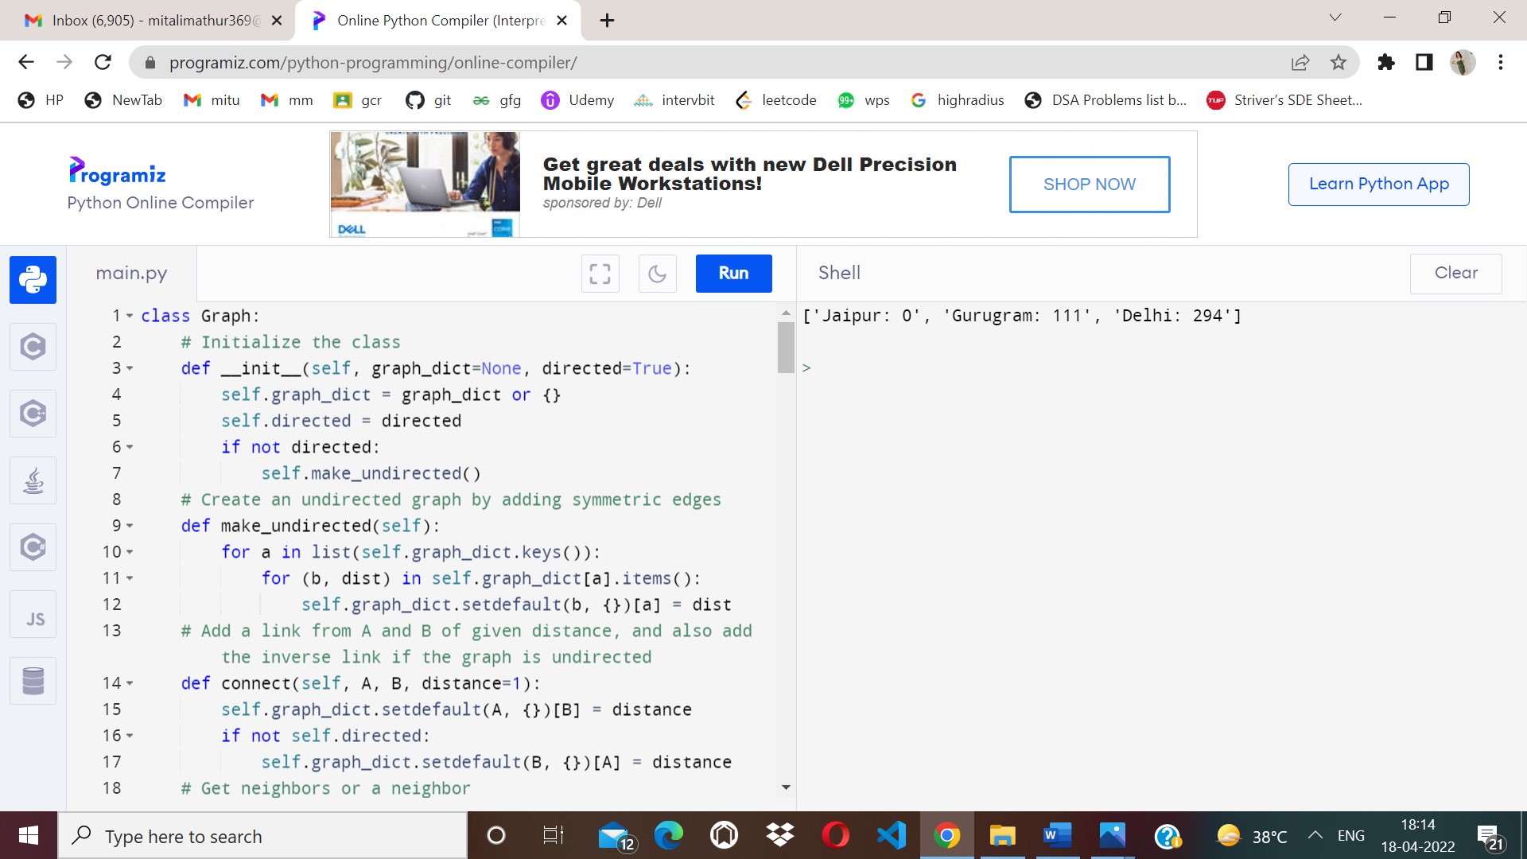

1. **A*-**

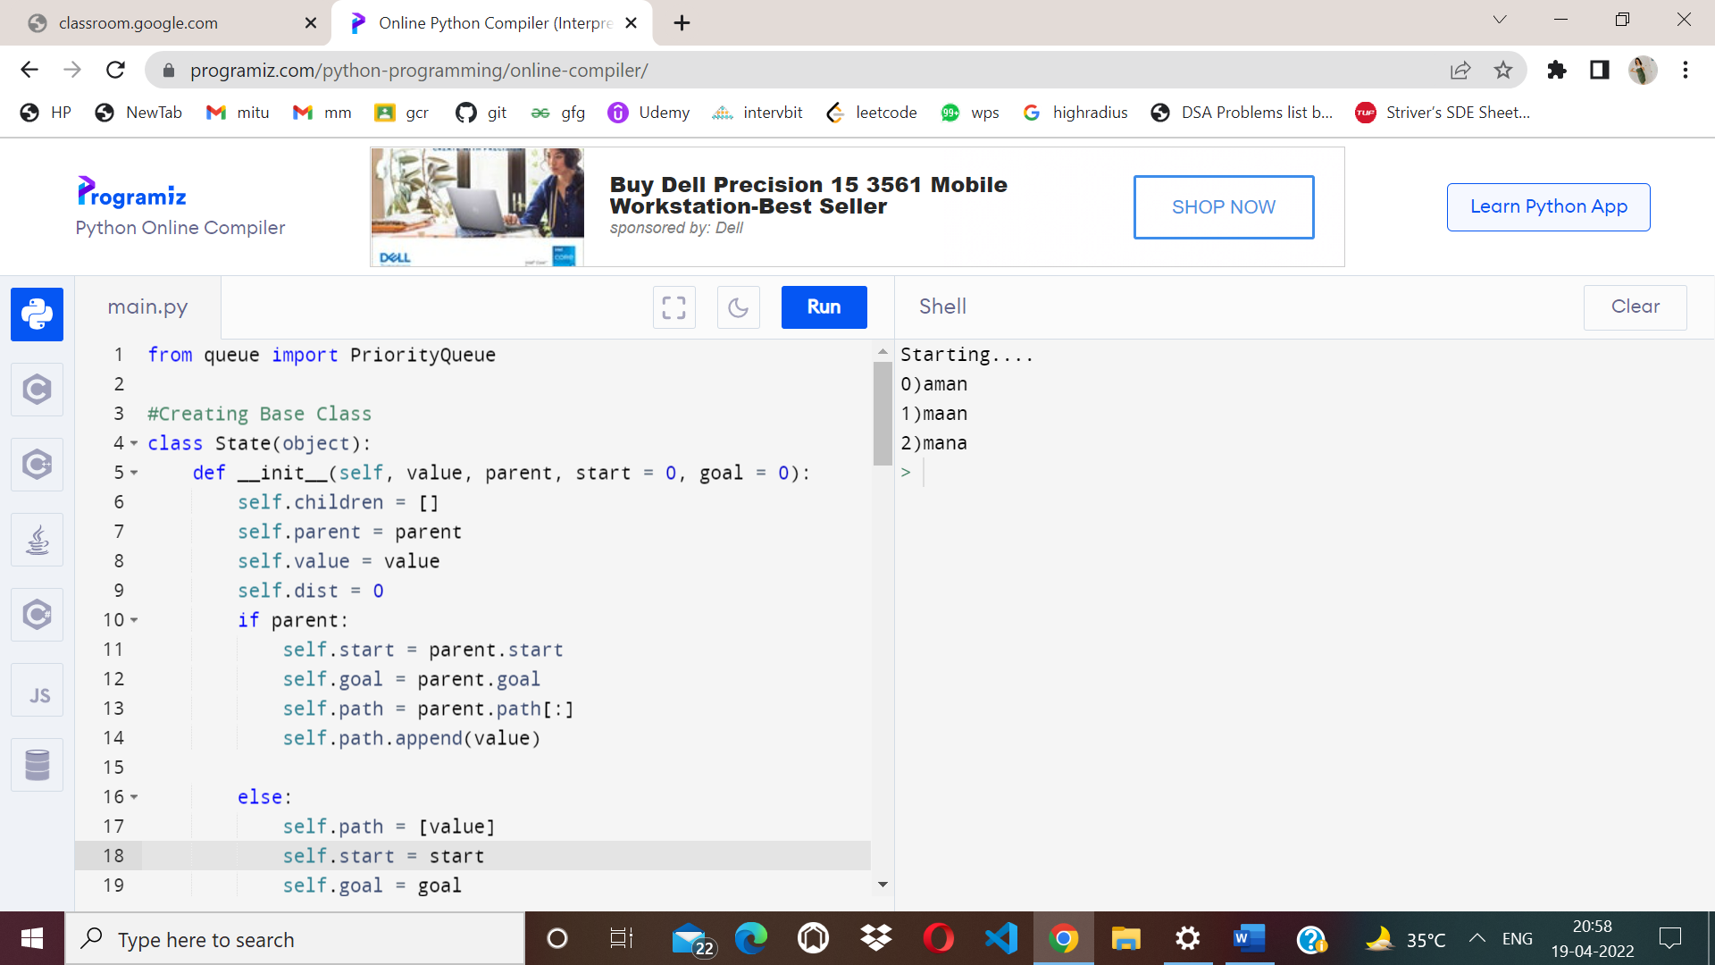

**Experiment 6**

* **Aim –** To implement Minimax Algorithm.
* **Algorithm –**

function minimax(node, depth, Player)

1.if depth ==0 or node is a terminal node then

return value(node)

2.If Player =‘Max’           // for **Maximizer Player**

       set **α = -∞**              //**worst case value for MAX**

 for each child of node do

 value= minimax(child, depth-1, ’MIN’)

α= max(α, Value)         //gives Maximum of the values

return  (α)

**else**                               // for **Minimizer player**

 set  **α = +∞**                         //**worst case value for MIN**

 for each child of node do

 value= minimax(child, depth-1, ’MAX’)

  α = min(α, Value)          //gives minimum of the values

return  (α)

* **Code –**

import math

def minimax (curDepth, nodeIndex, maxTurn, scores,targetDepth) :

if(curDepth==targetDepth):

return scores[nodeIndex]

if(maxTurn):

return max(minimax(curDepth+1, nodeIndex*2,False,scores,targetDepth),minimax(curDepth+1, nodeIndex*2+1,False,scores,targetDepth))

else:

return min(minimax(curDepth+1, nodeIndex*2,True,scores,targetDepth),minimax(curDepth+1, nodeIndex*2+1,True,scores,targetDepth))

scores=[-1,4,2,6,-3,-5,0,7]

treeDepth=math.log(len(scores),2)

print("Optimal value is : ",end=" ")

print(minimax(0,0,True,scores,treeDepth))

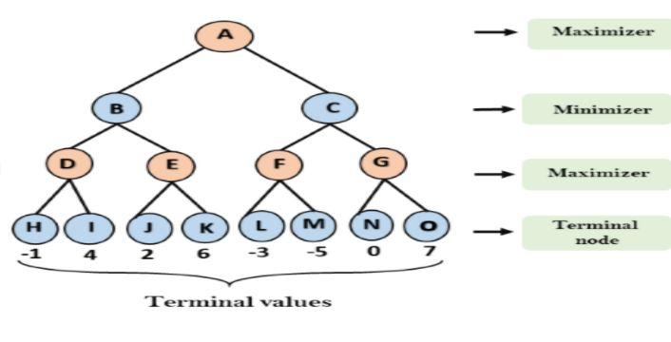

* **RESULT**:
* 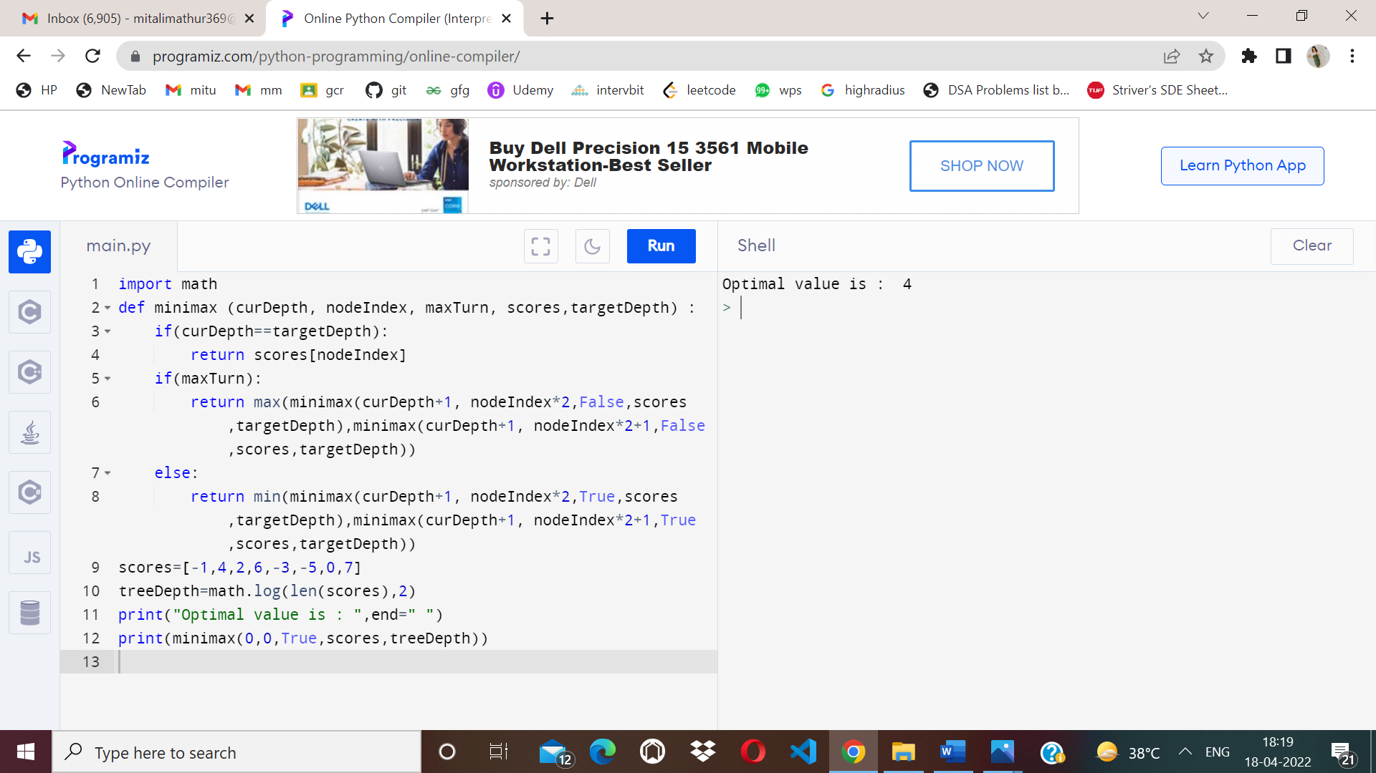

**Experiment 7**

* **Aim –** Implementation of unification and resolution for real world problems.
* **Algorithm–**

**Prolog unification**

When programming in Prolog, we spend a lot of time thinking about how variables and rules "match" or "are assigned." There are actually two aspects to this. The first, "unification," regards how terms are matched and variables assigned to make terms match. The second, "resolution," is described in [separate notes](https://cse3521.artifice.cc/prolog-resolution.html). Resolution is only used if rules are involved. You may notice in these notes that no rules are involved since we are only talking about unification.

**Terms**

Prolog has three kinds of **terms**:

1. Constants like 42 (numbers) and franklin (atoms, i.e., lower-case words).
2. Variables like X and Person (words that start with upper-case).
3. Complex terms like parent(franklin, bo) and baz(X, quux(Y))

Two terms **unify** if they can be matched. Two terms can be matched if:

* they are the same term (obviously), or
* they contain variables that can be unified so that the two terms without variables are the same.

For example, suppose our knowledge base is:

**woman**(mia).

**loves**(vincent, angela).

**loves**(franklin, mia).

* mia and mia unify because they are the same.
* mia and X unify because X can be given the value mia so that the two terms (without variables) are the same.
* woman(mia) and woman(X) unify because X can be set to mia which results in identical terms.
* loves(X, mia) and loves(vincent, X) **cannot** unify because there is no assignment for X (given our knowledge base) that makes the two terms identical.
* loves(X, mia) and loves(franklin, X) also cannot unify (can you see why?).

We saw in the [Prolog](https://cse3521.artifice.cc/prolog.html) notes that we can "query" the knowledge base and get, say, all the people who love mia. When we query with loves(X, mia). we are asking Prolog to give us all the values for X that unify. These values are, essentially, the people who love mia.

**Rule :**

term1 and term2 unify whenever:

1. If term1 and term2 are **constants**, then term1 and term2 unify if and only if they are the same atom, or the same number.
2. If term1 is a **variable** and term2 is any type of term, then term1 and term2 unify, and term1 is instantiated to term2. (And vice versa.) (If they are both variables, they're both instantiated to each other, and we say that they share values.)
3. If term1 and term2 are **complex terms**, they unify if and only if:

a. They have the same **functor** and **arity**. The functor is the "function" name (this functor is foo: foo(X, bar)). The arity is the number of arguments for the functor (the arity for foo(X, bar) is 2).

b. All of their corresponding arguments unify. **Recursion!**

c. The variable instantiations are compatible (i.e., the same variable is not given two different unifications/values).

1. Two terms unify if and only if they unify for one of the above three reasons (there are no reasons left unstated).

## Example

We'll use the = predicate to test if two terms unify. Prolog will answer "Yes" if they do, as well as any sufficient variable assignments to make the unification work.

**Do these two terms unify?**

**1.**

?- mia = mia.

**o/p Ans:-  Yes from Rule 1**

**2.**

?- mia = X.

**o/p Ans:-** Yes, from rule 2.

3.

?- X = Y.

o/p Yes, from rule 2.

4.

?- k(s(g), Y) = k(s(g, X), Y).

o/p

No, these two terms do not unify because arity of s(g) do not match with the arity of s(g,X) due to which rule 3 fails in recursion.

**Experiment 8**

* **Aim –** Implementation of knowledge representation schemes – use cases.
* **Semantic relations –**

1. 1. Ram has a cycle.

2. Ram is a boy.

3. Cycle has a bell.

4. Ram is 12 years old.

5. Cycle has two paddles.

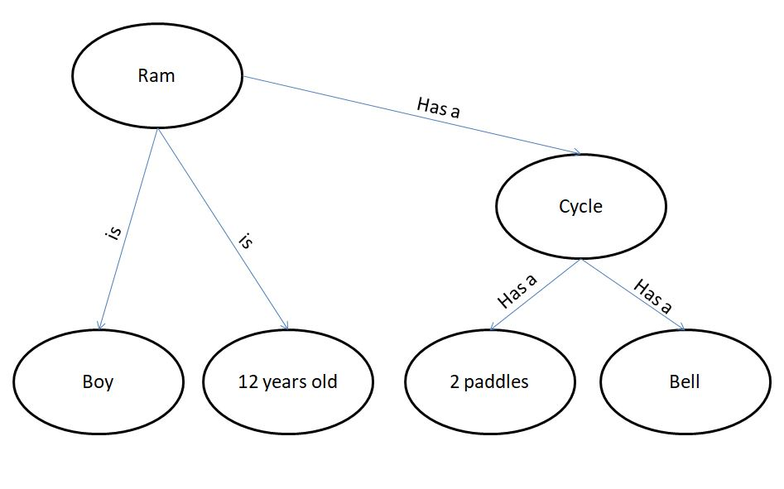B.

1. Gita likes all kinds of food.

2. Mango and chapati are food.

3. Gita eats almond and is still alive.

4. Anything eaten by anyone and is still alive is food.

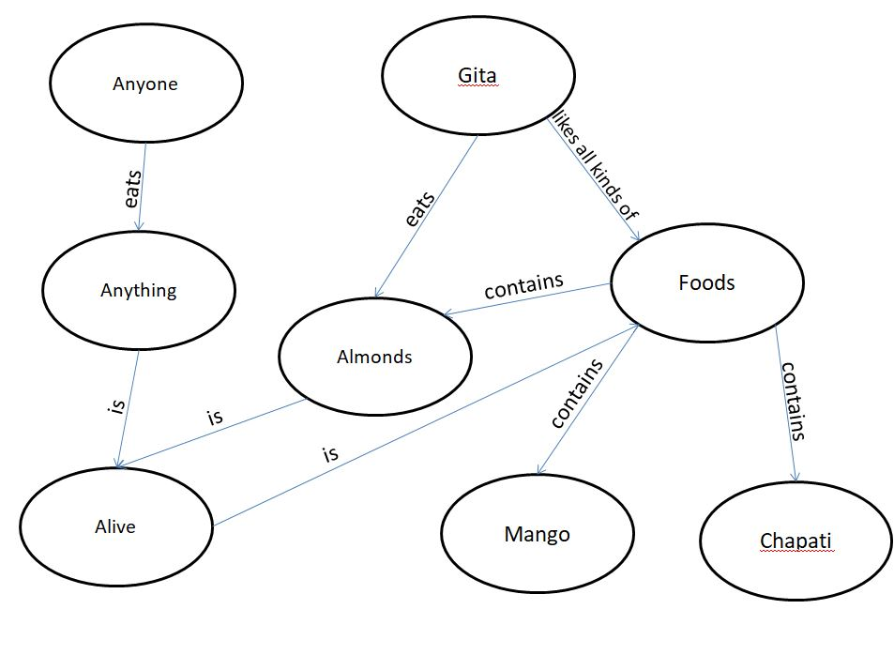

1. 1. Jerry is a cat.

2. Jerry is a mammal

3. Jerry is owned by Priya.

4. Jerry is brown colored.

5. All Mammals are animal.

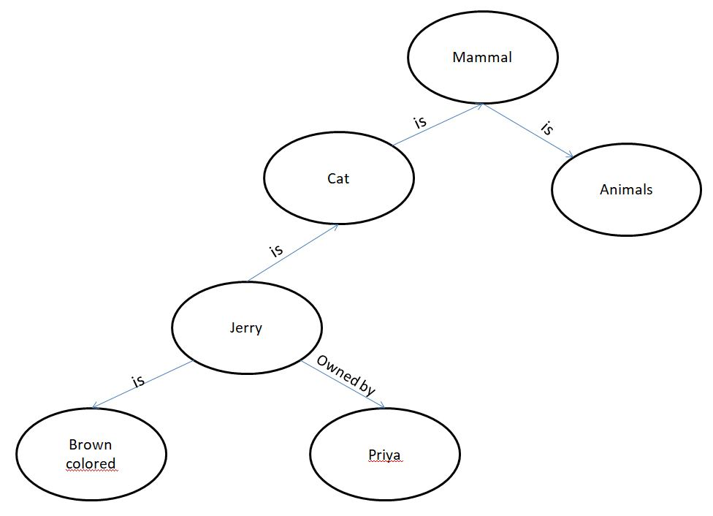

C. 1. Ritz is a car.

2. Car has 4 wheels.

3. Car is a vehicle.

4. Car has engine.

5. Car has battery.

6. Ritz has power steering.

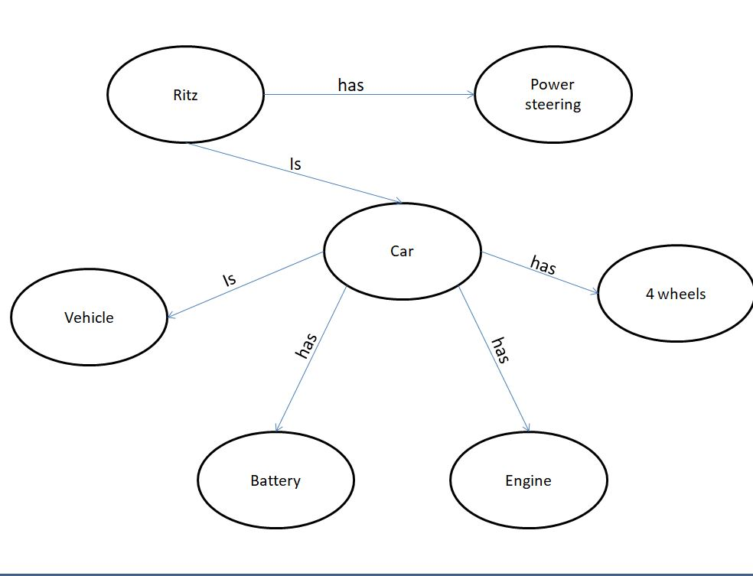

**Experiment 9**

* **Aim –** Implementation of uncertain methods for an application.
* **Algorithm–**

C:\Users\yashwant\Desktop\exp-9.png

we can find the probability of an uncertain event by using the above formula.

* **Code –**

**Problem1:-**

Calculate the Probability of finding how many students got the 60 marks for given data set .

import numpy as np

import collections

npArray= np.array([60, 70, 70, 70, 80,90,60])

c=collections.Counter(npArray) # Generate a dictionary {"value":"nbOfOccurrences"}

arraySize=npArray.size

nbOfOccurrences=c[60] #assuming you want the proba to get 10

proba=(nbOfOccurrences/arraySize)*100

print(proba) #print 60.0

**output:- 28.57**

**Problem2:-**

If In class 80 students and 60 students got 60 % marks then Calculate the Probability of finding how many students got the 60 marks for given data set .

#!/usr/bin/env python3

import sys

Marksprob = {}

for line in sys.stdin:

line = line.strip()

ClassA, Marks = line.split('\t', 1)

def event_probability(event_outcomes, sample_space):

probability = (event_outcomes / sample_space) * 100

return round(probability, 1)

ClassA = 30

Marks = 15

grade_probability = event_probability(Marks, ClassA)

print(str(grade_probability) + '%')

output:48%

**RESULT**:

The program has been executed successfully.

**Experiment 10**

* **Aim –** Implementation of block world problem.
* **Algorithm –**

1. MOVE(B,A)- To lift block from B to A.
2. ON(B,A)- To place block B on A.
3. CLEAR(B)- To lift block B from the table.
4. PLACE(B)- To put the block B on table.

* **Code –**

class Strips(object):

def __init__(self, name, preconds, effects, cost=1):

self.name = name

self.preconds = preconds

self.effects = effects

self.cost = cost

def __repr__(self):

return self.name

class STRIPS_domain(object):

def __init__(self, feats_vals, actions):

self.feats_vals = feats_vals

self.actions = actions

class Planning_problem(object):

def __init__(self, prob_domain, initial_state, goal):

self.prob_domain = prob_domain

self.initial_state = initial_state

self.goal = goal

boolean = {True, False}

### blocks world

def move(x,y,z):

"""string for the 'move' action"""

return 'move_'+x+'_from_'+y+'_to_'+z

def on(x):

"""string for the 'on' feature"""

return x+'_is_on'

def clear(x):

"""string for the 'clear' feature"""

return 'clear_'+x

def create_blocks_world(blocks = {'a','b','c','d'}):

blocks_and_table = blocks | {'table'}

stmap = {Strips(move(x,y,z),{on(x):y, clear(x):True, clear(z):True},

{on(x):z, clear(y):True, clear(z):False})}

for x in blocks:

for y in blocks_and_table:

for z in blocks:

if x!=y and y!=z and z!=x:

stmap.update({Strips(move(x,y,'table'), {on(x):y, clear(x):True},

{on(x):'table', clear(y):True})})

for x in blocks:

for y in blocks:

for z in blocks:

if x!=y:

feats_vals = {on(x):blocks_and_table-{x} for x in blocks}

feats_vals.update({clear(x):boolean for x in blocks_and_table})

return STRIPS_domain(feats_vals, stmap)

blocks1dom = create_blocks_world({'a','b','c'})

blocks1 = Planning_problem(blocks1dom,

{on('a'):'table', clear('a'):True,

on('b'):'c', clear('b'):True,

on('c'):'table', clear('c'):False}, # initial state

{on('a'):'b', on('c'):'a'}) #goal

blocks2dom = create_blocks_world({'a','b','c','d'})

tower4 = {clear('a'):True, on('a'):'b',

clear('b'):False, on('b'):'c',

clear('c'):False, on('c'):'d',

clear('d'):False, on('d'):'table'}

blocks2 = Planning_problem(blocks2dom,

tower4, # initial state

{on('d'):'c',on('c'):'b',on('b'):'a'}) #goal

blocks3 = Planning_problem(blocks2dom,

tower4, # initial state

{on('d'):'a', on('a'):'b', on('b'):'c'}) #goal

* **RESULT**:Goal achieved.
* **Output –**

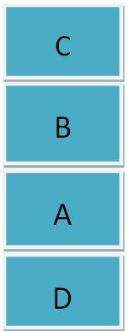

**Experiment 11**

* **Aim –** Implementation of Learning algorithm**.**
* **Code –**

List of Common Machine Learning Algorithms

* Linear Regression
* Logistic Regression
* Decision Tree
* SVM
* Naive Bayes
* KNN
* K-Means
* Random Forest

## 1. KNN (K-Nearest Neighbours)

K-Nearest Neighbors, KNN for short, is a supervised learning algorithm specialized in classification. It is a simple algorithm that stores all available cases and classifies new cases by a majority vote of its k neighbors.

from scipy.spatial import distance

class KNN():

def fit(self, X_train, Y_train):

self.X_train = X_train

self.Y_train = Y_train

def predict(self, X_test):

predictions = []

for row in X_test:

label = self.closest(row)

predictions.append(label)

return predictions

def closest(self, row):

best_dist = distance.euclidean(row, self.X_train[0])

best_index = 0

for i in range(1, len(self.X_train)):

dist = distance.euclidean(row, self.X_train[i])

if dist < best_dist:

best_dist = dist

best_index = i

return self.Y_train[best_index]

from sklearn import datasets

iris = datasets.load_iris()

X = iris.data

Y = iris.target

from sklearn.cross_validation import train_test_split

X_train, X_test, Y_train, Y_test = train_test_split(X, Y, test_size = .75)

from sklearn.neighbors import KNeighborsClassifier

classifier = KNN()

classifier.fit(X_train, Y_train)

predictions = classifier.predict(X_test)

from sklearn.metrics import accuracy_score

print accuracy_score(Y_test, predictions)

OUTPUT::



2. Linear Regression

Linear regression is used to estimate real world values like cost of houses, number of calls, total sales etc.

### Example

The best way to understand linear regression is by considering an example. Suppose we are asked to arrange students in a class in the increasing order of their weights.

# sample points

X = [0, 6, 11, 14, 22]

Y = [1, 7, 12, 15, 21]

# solve for a and b

def best_fit(X, Y):

xbar = sum(X)/len(X)

ybar = sum(Y)/len(Y)

n = len(X) # or len(Y)

numer = sum([xi*yi for xi,yi in zip(X, Y)]) - n * xbar * ybar

denum = sum([xi**2 for xi in X]) - n * xbar**2

b = numer / denum

a = ybar - b * xbar

print('best fit line:\ny = {:.2f} + {:.2f}x'.format(a, b))

return a, b

# solution

a, b = best_fit(X, Y)

#best fit line:

#y = 0.80 + 0.92x

# plot points and fit line

import matplotlib.pyplot as plt

plt.scatter(X, Y)

yfit = [a + b * xi for xi in X]

plt.plot(X, yfit)

plt.show()

best fit line:

y = 1.48 + 0.92x

* **Output:-**

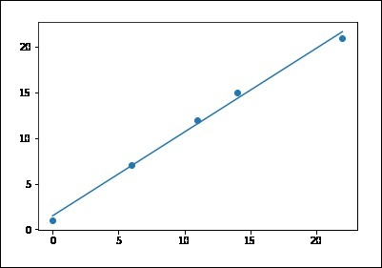

**Experiment 12**

* **Aim –** Development of ensemble model.
* **Code –**

An Ensemble method creates multiple models and combines them to solve it. Ensemble methods help to improve the robustness of the model.

**Basic Ensemble Techniques**  
1 Max Voting  
2 Averaging  
3 Weighted Average

Problem: Development of ensemble model using Averaging Technique.

**Averaging method:** It is mainly used for regression problems. The method consists of build multiple models independently and returns the average of the prediction of all the models. In general, the combined output is better than an individual output because variance is reduced.

In the below example, three regression models (linear regression, xgboost, and random [forest](https://text-to-search.com/s/?q=forest)) are trained and their predictions are averaged. The final prediction output is pred_final.

# importing utility modules

import pandas as pd

from sklearn.model_selection import train_test_split

from sklearn.metrics import mean_squared_error

# importing machine learning models for prediction

from sklearn.ensemble import RandomForestRegressor

import xgboost as xgb

from sklearn.linear_model import LinearRegression

# loading train data set in dataframe from train_data.csv file

df = pd.read_csv("train_data.csv")

# getting target data from the dataframe

target = df["target"]

# getting train data from the dataframe

train = df.drop("target")

# Splitting between train data into training and validation dataset

X_train, X_test, y_train, y_test = train_test_split(

train, target, test_size=0.20)

# initializing all the model objects with default parameters

model_1 = LinearRegression()

model_2 = xgb.XGBRegressor()

model_3 = RandomForestRegressor()

# training all the model on the training dataset

model_1.fit(X_train, y_target)

model_2.fit(X_train, y_target)

model_3.fit(X_train, y_target)

# predicting the output on the validation dataset

pred_1 = model_1.predict(X_test)

pred_2 = model_2.predict(X_test)

pred_3 = model_3.predict(X_test)

# final prediction after averaging on the prediction of all 3 models

pred_final = (pred_1+pred_2+pred_3)/3.0

# printing the root mean squared error between real value and predicted value

print(mean_squared_error(y_test, pred_final))

Input:-

|  |  |  |  |  |  |  |
| --- | --- | --- | --- | --- | --- | --- |
|  | Colleague 1 | Colleague 2 | Colleague 3 | Colleague 4 | Colleague 5 | Final rating |
| Rating | 5 | 4 | 5 | 4 | 4 | 4.4 |

Output: - final rating will be 4.4

**RESULT**:Program compiled successfully.

**Experiment 13**

* **Aim –** Implementation of NLP problem.
* **Code –**

**Problem**:-

Count total number of adjective and noun

# Import data and tagger

from nltk.corpus import twitter_samples

from nltk.tag import pos_tag_sents

# Load tokenized tweets

tweets_tokens = twitter_samples.tokenized('positive_tweets.json')

# Tag tagged tweets

tweets_tagged = pos_tag_sents(tweets_tokens)

# Set accumulators

JJ_count = 0

NN_count = 0

# Loop through list of tweets

for tweet in tweets_tagged:

for pair in tweet:

tag = pair[1]

if tag == 'JJ':

JJ_count += 1

elif tag == 'NN':

NN_count += 1

# Print total numbers for each adjectives and nouns

print('Total number of adjectives = ', JJ_count)

print('Total number of nouns = ', NN_count)

* **Result –**

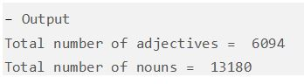

**Experiment 14**

**Aim –**Deep learning Project in Python

**Code-**

# Import pandas

import pandas as pd

# Read in white wine data

white = pd.read_csv("http://archive.ics.uci.edu/ml/machine-learning-databases/wine-quality/winequality-white.csv", sep=';')

# Read in red wine data

red = pd.read_csv("http://archive.ics.uci.edu/ml/machine-learning-databases/wine-quality/winequality-red.csv", sep=';')

import matplotlib.pyplot as plt

fig, ax = plt.subplots(1, 2)

ax[0].hist(red.alcohol, 10, facecolor='red', alpha=0.5, label="Red wine")

ax[1].hist(white.alcohol, 10, facecolor='white', ec="black", lw=0.5, alpha=0.5, label="White wine")

fig.subplots_adjust(left=0, right=1, bottom=0, top=0.5, hspace=0.05, wspace=1)

ax[0].set_ylim([0, 1000])

ax[0].set_xlabel("Alcohol in % Vol")

ax[0].set_ylabel("Frequency")

ax[1].set_xlabel("Alcohol in % Vol")

ax[1].set_ylabel("Frequency")

#ax[0].legend(loc='best')

#ax[1].legend(loc='best')

fig.suptitle("Distribution of Alcohol in % Vol")

plt.show()

**Output:**

